1. What are the different margins options and do we adjust the margins of

the excel worksheet?

To use predefined margins, click **Normal, Wide, or Narrow**. Tip: If you previously used a custom margin setting, that setting is available as the Last Custom Setting option. To specify custom page margins, click Custom Margins and then—in the Top, Bottom, Left, and Right boxes—enter the margin sizes that you want.

2. Set a background for your table created.

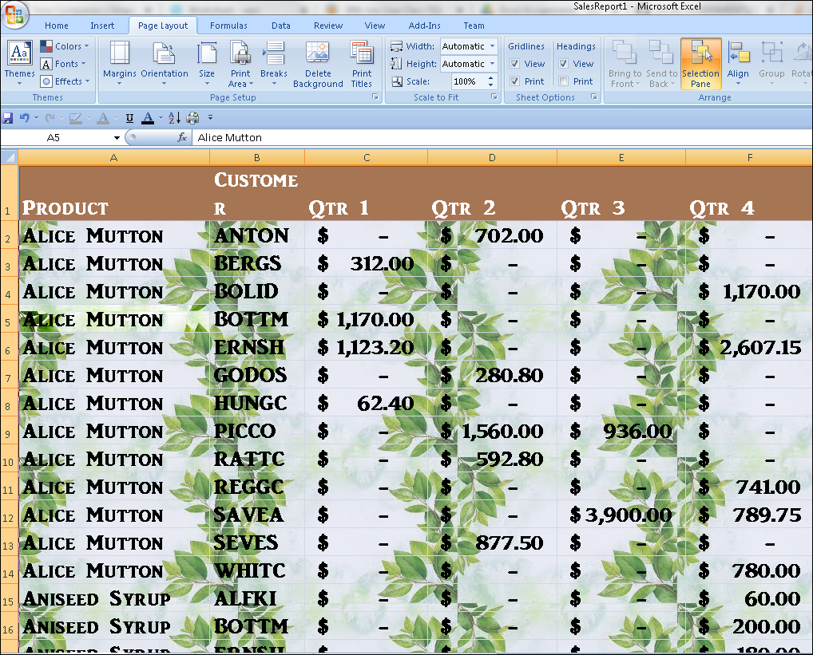

3. What is freeze panes and why do we use freeze panes? Give

examples.

**To keep an area of a worksheet visible while you scroll to another area of the worksheet**, go to the View tab, where you can Freeze Panes to lock specific rows and columns in place, or you can Split panes to create separate windows of the same worksheet

4. What are the different features available within the Freeze Panes

command?

1.

In the windows group, go to the View tab, and click Freeze Panes. Click Freeze Top Row.

2.

Go to View > Freeze Panes > Unfreeze Panes.Click on Unfreeze Panes.

3.

Go to View tab > Windows group > Freeze First Column. Select Freeze First Column.

5. Explain what the different sheet options present in excel are and what

they do?

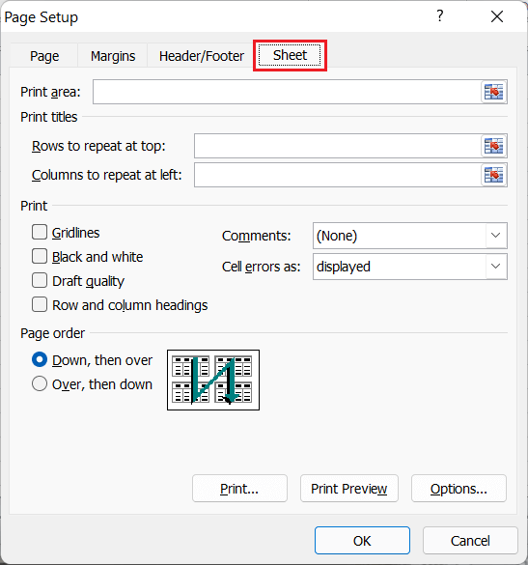

* **Print Area:** We can select the print area using this option. We can drag and select the area or range of cells by using the mouse.
* **Print Titles:**
  + **Rows to repeat at top:** This option helps us select the title to display at the top for corresponding rows.
  + **Columns to repeat at left:** This option helps us select the title to display on the left side for columns.
* **Print:**
  + **Gridlines:** This option can be enabled or disabled by selecting/ deselecting the checkbox. It helps us decide whether to show gridlines or not on printed Excel documents.
  + **Black & White:** Like the gridlines, we can select this checkbox to print the current Excel document in black and white color, even if we have the color printer attached.
  + **Draft Quality:** Selecting the checkbox associated with the draft quality allows us to print the Excel document using the printer's draft-quality settings.
  + **Rows & Column Heading:** We can select this option to display rows and columns headings to the printed Excel documents.
* **Page Order:**
  + **Down, then Over:** This option allows users to print the down page first and then the right pages.
  + **Over, then Down:** This option allows users to print the right pages first and then the down pages.
* **Print:** Clicking on this option gives a command to the device to print the current Excel document using the default printer.
* **Print Preview:** This option displays the preview of the Excel document that will be printed on paper.
* **Options:** This option allows users to choose layout type (portrait or landscape) and paper mode (A4, A5, etc.) for the Excel document to be printed.

Excel has all the basic and advanced options present on its ribbon. Likewise, some quick sheet options are also present on the Excel ribbon and can be accessed by going to **Page Layout > Sheet Options.** It mainly has four toggle options: two for **Gridlines** and two for **Headings,** and they can be turned on and off by selecting and deselecting the checkboxes.

* **Gridlines:**
  + **View:** This option allows users to show/ hide gridlines within the active worksheet. Turning off this option removes the gridlines from the sheet and displays a blank Excel sheet.
  + **Print:** This option allows users to show/ hide gridlines on an Excel document that will be printed on paper.
* **Headings:**
  + **View:** This option allows users to show/ hide headings within the active worksheet. Turning off this option removes the headings from the current sheet's headers and footers.
  + **Print:** This option allows users to show/ hide headings on an Excel document, which is to be printed on paper.

The above sheet options are worksheet-specific, and changes are only applied to the active worksheet. This means that we have to adjust these options again for the new worksheets and workbooks.

